# USEFUL FORMULAS AND CONVERSION FACTORS

**Useful Formulas**

## Spray Rates

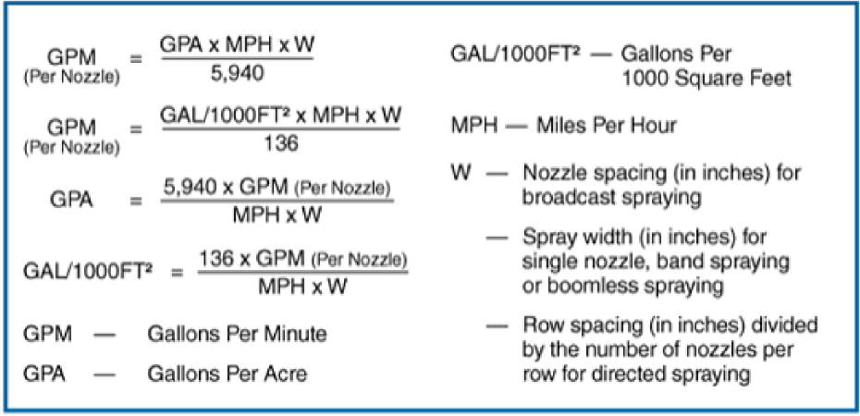

**Nozzle Spacing Equivalents**

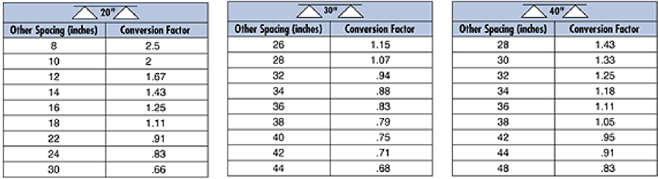

**Nozzle Selection Formula**

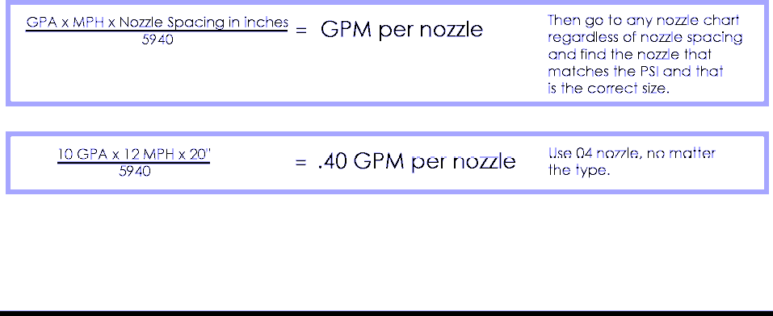

**USEFUL FORMULAS AND CONVERSION FACTORS**

**Low Limit Formula**

Use this formula to determine the low limit (in gallons per acre) for all nozzles and boom lengths.



### Example

The following calculation uses nozzle number 8004 and a 90’ boom with 20” spacing.



## Spraying with Liquids with a Density Other Than Water

All the previous tabulations are based on spraying water, which weighs 8.34 lbs per US Gallon (1 kg per Liter). Conversion factors must be used when spraying liquids that are heavier or lighter than water to select the correct nozzle. Refer to the following table:

|  |  |  |
| --- | --- | --- |
| **Weight of Solution** | **Specific Gravity** | **Conversion Factor** |
| 7.0 lbs/gal. | 0.84 | 0.92 |
| 8.0 lbs/gal. | 0.96 | 0.88 |
| 8.34 lbs/gal. | 1.00 (water) | 1.00 |
| 9.0 lbs/gal. | 1.08 | 1.04 |
| 10.0 lbs/gal. | 1.20 | 1.10 |
| 10.65 lbs/gal. | 1.28 (28% nitrogen) | 1.13 |
| 11.0 lbs/gal. | 1.32 | 1.15 |
| 12.0 lbs/gal. | 1.44 | 1.20 |
| 14.0 lbs/gal. | 1.68 | 1.30 |

To determine the proper sized nozzle for liquids heavier or lighter than water, first multiply the desired GPM or GPA by the water rate conversion factor, then use the converted GPM or GPA rate to select the proper nozzle size.



### Example

The following calculation uses a desired application of 20 GPA of 28% nitrogen.



In this example, a nozzle that supplies 22.6 GPA of water at the desired pressure, will supply 20 GPA of 28% nitrogen at the same pressure.

51

# USEFUL FORMULAS AND CONVERSION FACTORS

## Additional Conversion Factors

|  |  |
| --- | --- |
| One Acre | = 43.560 square feet  = 43.56 1000FT2 blocks  = 0.405 Hectare |
| One Hectare | = 2.41 Acres |
| One Gallon Per Acre (GPA) | = 2.9 Fluid Ounces per 1000FT2  = 9.35 Liters per Hectare |
| One Gallon Per 1000FT2 | = 43.56 GPA |
| One Mile | = 5,280 Feet  = 1,610 Meters  = 1.61 Kilometers |
| One Gallon | = 128 Fluid Ounces  = 8 Pints  = 4 Quarts  = 3.79 Liters  = 0.83 Imperial Gallon |
| One Pound Per Square Inch (PSI) | = 0.069 bar  = 6.896 Kilopascals |